UNITED STATES
SECURITIES AND EXCHANGE COMMISSION
Washington, D.C. 20549

SCHEDULE 14A

Proxy Statement Pursuant to Section 14(a) of the
Securities Exchange Act of 1934

Filed by the Registrant ☒

Filed by a Party other than the Registrant ☐

Check the appropriate box:

☐ | Preliminary Proxy Statement
☐ | Confidential, for Use of the Commission Only (as permitted by Rule 14a-6(e)(2))
☐ | Definitive Proxy Statement
☒ | Definitive Additional Materials
☐ | Soliciting Material Pursuant to Section 240.14a-12

NEONC TECHNOLOGIES HOLDINGS, INC.

(Name of Registrant as Specified In Its Charter)

(Name of Person(s) Filing Proxy Statement, if other than the Registrant)

Payment of Filing Fee (Check the appropriate box):

☒ | No fee required.
☐ | Fee paid previously with preliminary materials.
☐ | Fee computed on table in exhibit required by Item 25(b) per Exchange Act Rules 14a6(i)(1) and 0-11.

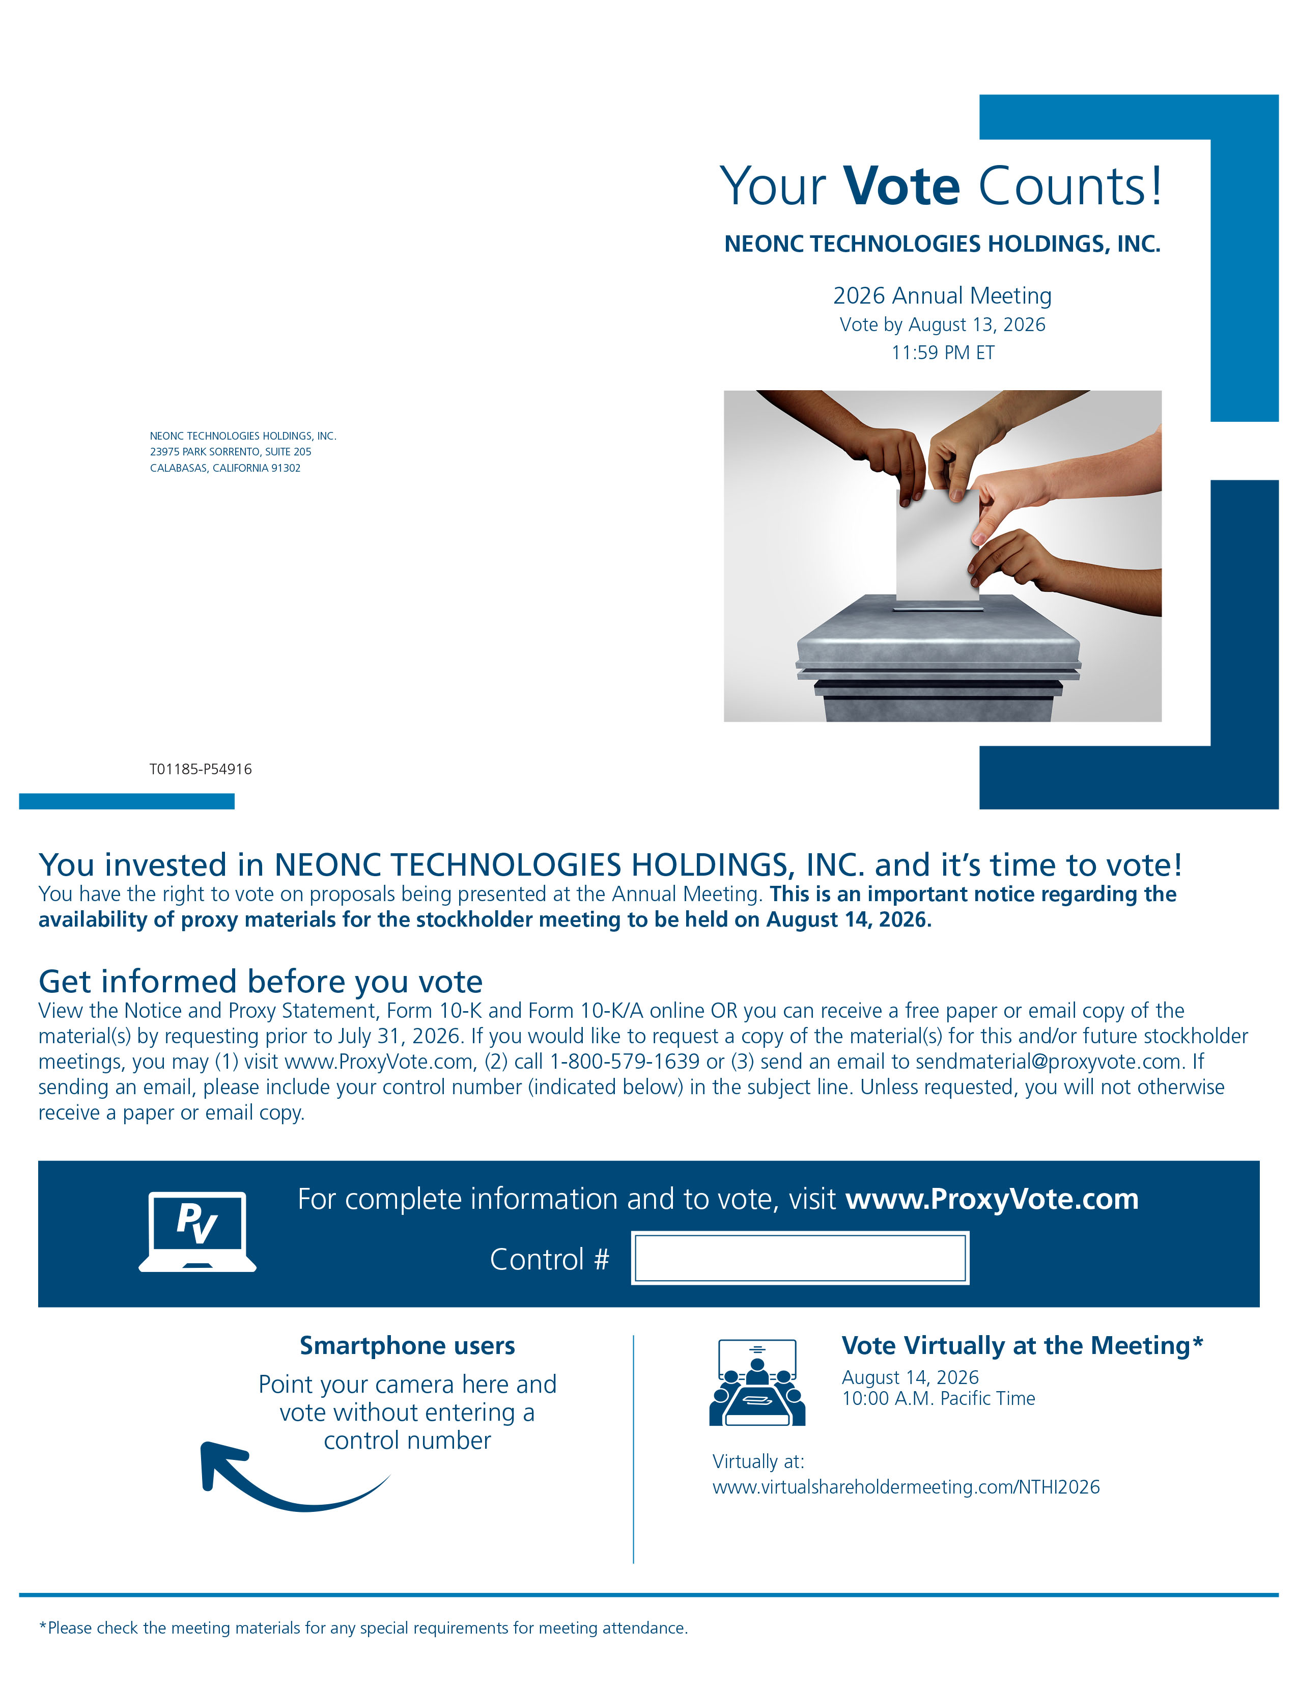
Y our V ote Counts! NEONC TECHNOLOGIES HOLDINGS, INC. 2026 Annual Meeting Vote by August 13, 2026 11:59 PM ET NEONC TECHNOLOGIES HOLDINGS, INC. 23975 P ARK SORRENTO, SUITE 205 CALABASAS, CALIFORNIA 91302 Y ou invested in NEONC TECHNOLOGIES HOLDINGS, INC. and it ’ s time to vote! Y ou have the right to vote on p r oposals being p r esented at the Annual Meeting. This is an important notice r ega r ding the availability of p r oxy materials for the stockholder meeting to be held on August 14, 2026. Get informed before you vote V iew the Notice and P r oxy Statement, Form 10 - K and Form 10 - K/A online OR you can r eceive a f r ee paper or email copy of the material(s) by r equesting prior to July 31, 2026. If you would like to r equest a copy of the material(s) for this and/or futu r e stockholder meetings, you may (1) visit ww w .P r oxy V ote.com, (2) call 1 - 800 - 579 - 1639 or (3) send an email to sendmaterial@p r oxyvote.com. If sending an email, please include your cont r ol number (indicated below) in the subject line. Unless r equested, you will not otherwise r eceive a paper or email cop y . For complete information and to vote, visit ww w .P r oxy V ote.com Cont rol # V ote V irtually at the Meeting* August 14, 2026 10:00 A.M. Pacific T ime V irtually at: ww w .virtualsha r eholdermeeting.com/NTHI2026 *Please check the meeting materials for any special requirements for meeting attendance. Smartphone users Point your camera he r e and vote without entering a cont r ol number T01185 - P54916

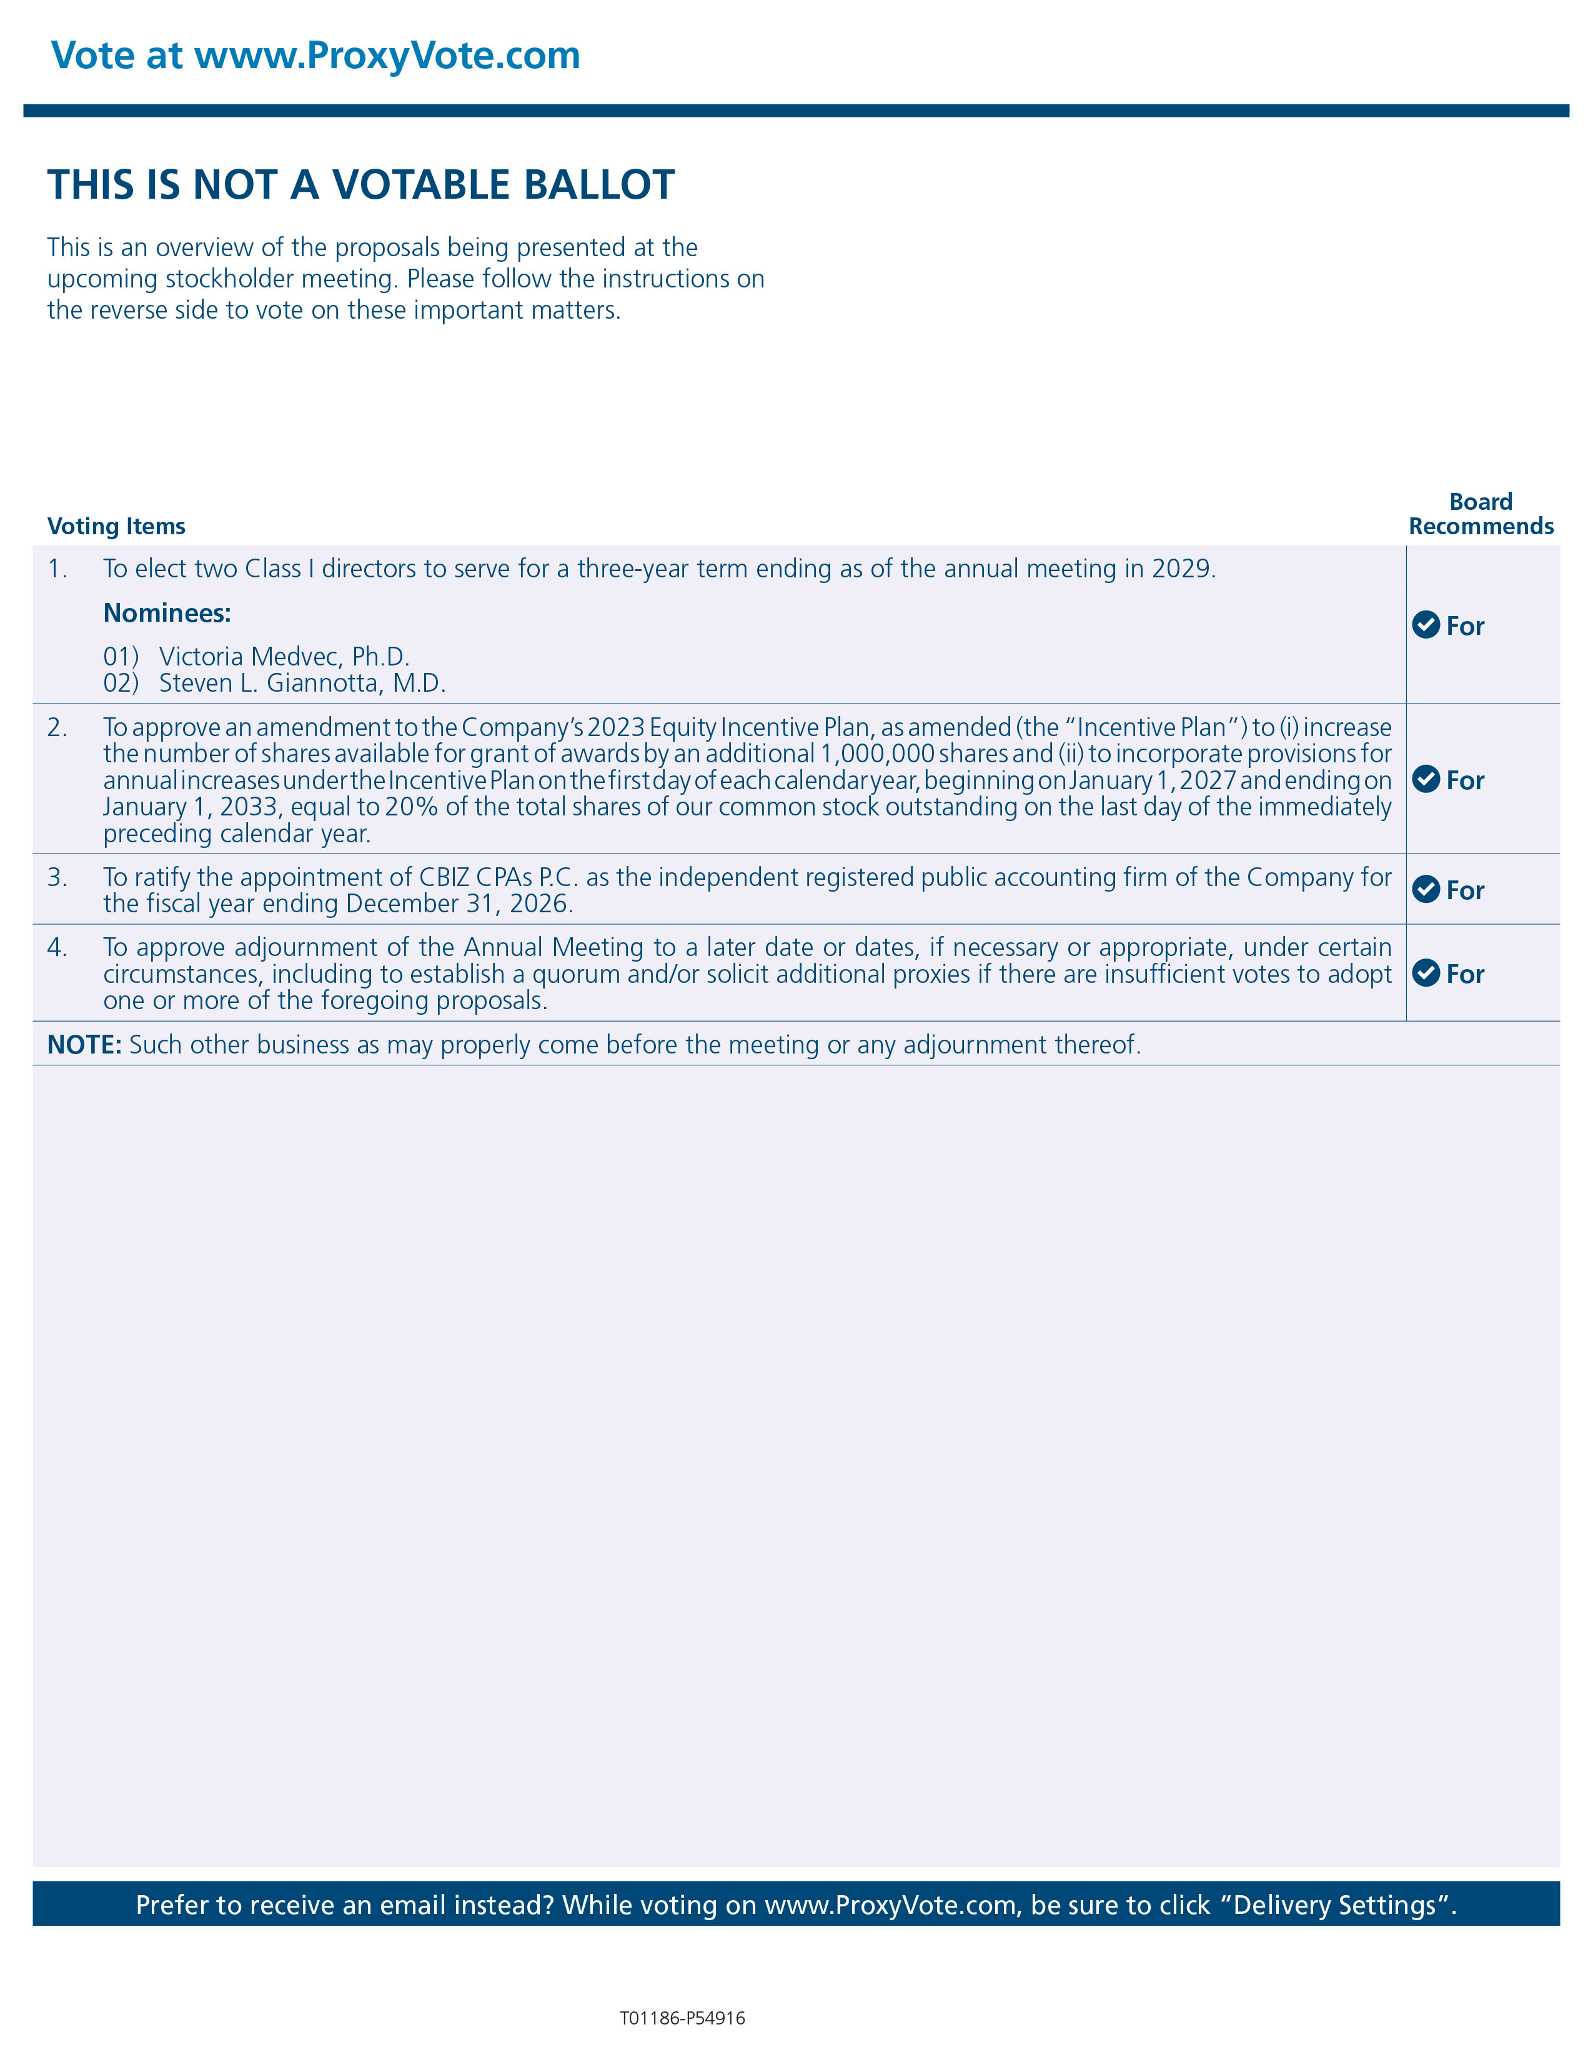
V ote at ww w .P r oxy V ote.com THIS IS NOT A VO T ABLE BALLOT This is an overview of the p r oposals being p r esented at the upcoming stockholder meeting. Please follow the instructions on the r everse side to vote on these important matters. Prefer to receive an email instead? While voting on ww w .Proxy V ote.com, be sure to click “Delivery Settings”. V oting Items Boa r d Recommends T01186 - P54916 1. T o elect two Class I di r ectors to serve for a th r ee - year term ending as of the annual meeting in 2029. Nominees: 1) V ictoria Medvec, Ph.D. 2) Steven L. Giannotta, M.D. For 2 . T o app rove an amendment to the Company ’ s 2023 Equity Incentive Plan, as amended (the “Incentive Plan”) to (i) inc r ease the number of sha r es available for grant of awa r ds by an additional 1 , 000 , 000 sha r es and (ii) to incorporate p rovisions for annua l inc r eases under the Incentive Plan on the first day of eac h calenda r yea r , beginning on January 1 , 2027 an d ending on January 1 , 2033 , equal to 20 % of the total sha r es of our common stock outstanding on the last day of the immediately p r eceding calendar yea r . For 3. T o ratify the appointment of CBIZ C P As P .C. as the independent r egiste r ed public accounting firm of the Company for the fiscal year ending December 31, 2026. For 4 . T o app rove adjou r nment of the Annual Meeting to a later date or dates, if necessary or app r opriate, under certain ci r cumstances, including to establish a quorum and/or solicit additional p roxies if the r e a r e insu f ficient votes to adopt one or mo r e of the fo r egoing p r oposals . For NOTE: Such other business as may p r operly come befo r e the meeting or any adjou r nment the r eof.

